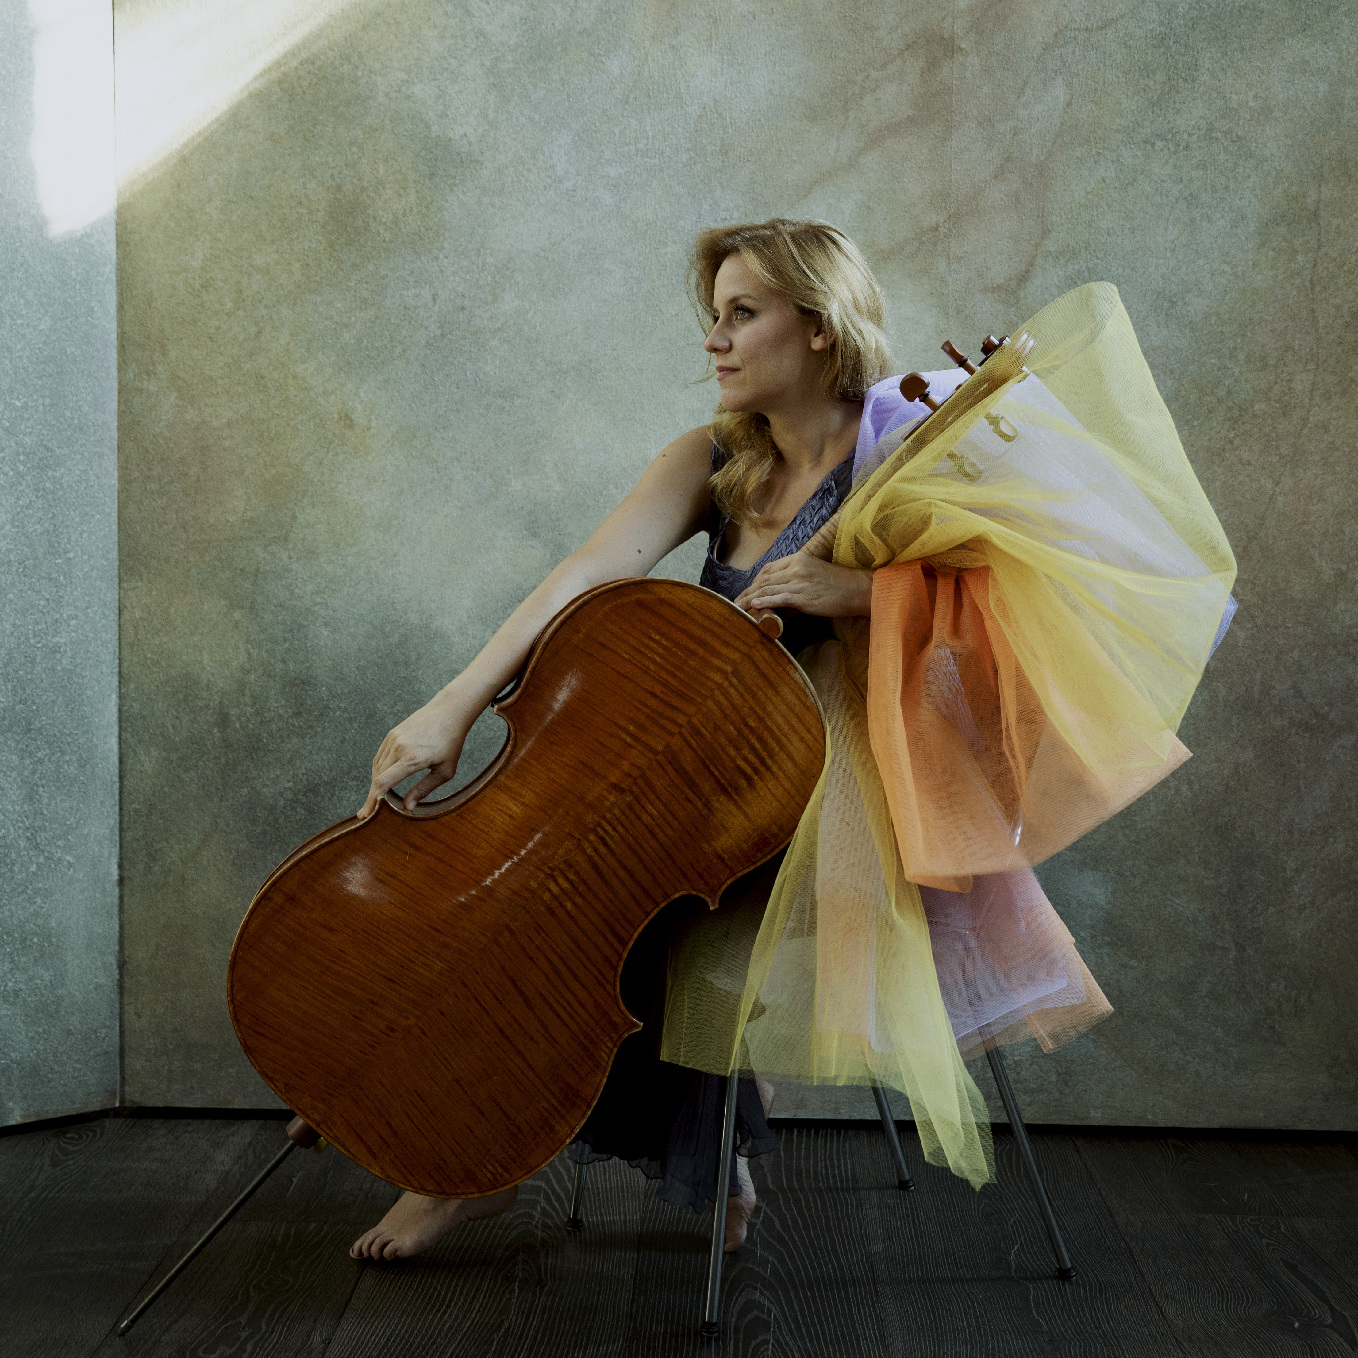
BIOGRAPHY

Following her recital debut at Carnegie’s Weill Hall, The Strad hailed cellist Maja Bogdanović for “an outstanding performance of exceptional tonal beauty”. She has since taken her place among today’s foremost cellists as a soloist, chamber musician and educator. Concerto engagements have included the Tonhalle Orchester Zürich, Tokyo Philharmonic, Minas Gerais Symphony, Munich Chamber Orchestra, Belgrade Philharmonic, Berliner Symphoniker, Johannesburg Philharmonic, Cape Town Philharmonic, and the English Symphony Orchestra.

Maja made her U.S. debut in 2017 at the Grand Teton Music Festival under the baton of Cristian Măcelaru, and has since appeared as a soloist with the Fort Worth Symphony, Spokane Symphony, and Lubbock Symphony. An avid chamber musician, Maja Bogdanović is a frequent guest at the world’s leading chamber music festivals such as the Kuhmo Festival in Finland, Cello Biënnale Amsterdam, Festival Radio France Occitanie Montpellier, Folle Journée/Nantes, Storioni Festival, and the Stift International Chamber Music Festival in The Netherlands, performing with artists such as Martha Argerich, Yuri Bashmet, Julian Rachlin, Nino Gvetadze, Daniel Rowland, Nemanja Radulovic, Anna Fedorova and Marianna Shirinyan.
In 2023, the new Arethusa Quartet was born. It brings Maja together with the like-minded spirits of violinists Daniel Rowland and Floor Le Coultre, and violist Dana Zemtsov.

Maja has released several internationally praised albums for the Lyrinx, Nimbus, DUX and Orchid Classics labels. Her releases for Challenge Records include the ‘Pas de Deux’ with violinist Daniel Rowland, which features world premiere recordings of works by Penderecki, Vasks, Sollima and Nisinman. It was described as “a magical meeting of cello and violin” by Dutch daily NRC. In 2023, she released Lalo & Saint-Saëns Cello Concertos together with the RTS Symphony Orchestra and conductor Bojan Sudjić. It led to rave reviews in a.o. NRC and De Volkskrant, 5-star reviews in Diapason and Classica, Preis der Deutschen Schallplattenkritik nomination, Podium Klassiek TV performance, the cover story of Cliq Musique, and articles in The Strad and Luister Magazine. Scherzo wrote that “Her sound is silky, bright but intimate, seductive but fierce - imperial in all registers.” Diapason concluded that “This magnificent French program confirms that Maja Bogdanović is one of the most interesting performers today.”
Maja has premiered works of Nicolas Bacri, Sofia Gubaidulina, Krzysztof Penderecki, Philip Sawyers, Eric Tanguy, Benjamin Yusupov, Nataša Bogojević, Isidora Žebeljan, and Pēteris Vasks. Her collaboration with Krzysztof Penderecki began with the Belgrade Philharmonic in 2008, and with the Slovenian Philharmonic in Ljubljana, where she performed his Cello Concerto No. 2 under the baton of the composer.
Maja collaborated with the Phion Orchestra and conductor David Cohen to perform and record Osvaldo Golijov’s cello concerto “Azul” at the Stift Festival in August 2024, in the inspiring presence of the composer himself.
Recent highlights include concertos with the Belgrade Philharmonic Orchestra, Montenegrin Symphony Orchestra, Cape Town Philharmonic Orchestra, Johannesburg Philharmonic Orchestra, Bad Reichenhaller Philharmoniker and the Princeton Symphony Orchestra, as well as various recitals and chamber music engagements with Daniel Rowland, Anna Fedorova, ACE (Amsterdam Chamber Ensemble) and the new Arethusa Quartet.
Born in Belgrade, Serbia, Maja began playing the cello at a very early age, studying with Professor Nada Jovanovic in Zemun. She went on to graduate with a First Prize from the Conservatoire National Supérieur de Musique de Paris, where she completed her postgraduate course with Michel Strauss. While there, she also studied chamber music with Itamar Golan and Pierre-Laurent Aimard. Following her studies in Paris, she pursued further training at the Universität der Künste Berlin with Professor Jens Peter Maintz. Laureate of numerous international competitions, Maja won First Prize at the third Aldo Parisot Cello Competition in South Korea and received the Second Prize and Special Audience Award at the Gaspar Cassado International Competition in Tokyo. She was awarded the Special Prize at the Concours Rostropovich in Paris.

Maja’s instrument was custom made for her by French luthier Frank Ravatin. She lives in Amsterdam with her husband Daniel Rowland and their two daughters.

